Advanced Yield Curve Calibration, Mixed Interpolation Schemes

& How to Incorporate Jumps and the Turn-of-Year Effect

Saïd Business School, Oxford University

Nicholas Burgess

[nicholas.burgess@sbs.ox.ac.uk](mailto:nicholas.burgess@sbs.ox.ac.uk)

[nburgessx@gmail.com](mailto:nburgessx@gmail.com)

August 2021

Abstract

Yield curves are used to imply the forward rates and discount factors from market tradable instruments and are required to discount future cash flows and evaluate the price of all financial contracts. Not all instruments can be included in the yield curve calibration or fitting process, hence we interpolate any gaps and missing forward rates. In this paper we discuss interpolation best practise and how to incorporate market jumps and turn of year (ToY) effects into yield curve calibration.

Advanced Curves

Advanced yield curves are required to be highly accurate to typically to 1/10th of a basis point[1] at a minimum if they are to be considered suitable for trading purposes. To reach this high standard of accuracy it is important that yield curves fit market dynamics well with a suitable interpolation scheme as determined by market instruments.

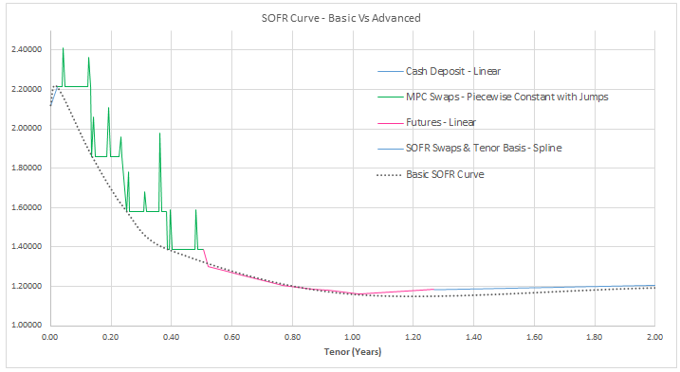

**Figure 1**: USD SOFR Yield Curve with Mixed Interpolation

Hybrid or Mixed Interpolation

To calibrate a yield curve to match market prices, mixed interpolation and careful consideration of instrument joins and overlaps is required. Additionally one has to cater for the turn-of-year effect and jumps in yield curve forward rates. Basic yield curves without this ability will result in swap quotes being off-market, as illustrated in (figure 1) where we compare a basic and advanced USD SOFR[2] yield curve.

Interpolation Best Practise by Calibration Instrument

* Cash Deposits Linear Interpolation
* Monetary Policy Swaps[3] Piecewise Constant (flat) with Jumps
* Futures Linear Interpolation
* Swaps Smooth Interpolation e.g. spline

Forward Rate Turns and Jumps

A key consideration when building and calibrating yield curves is how to incorporate the potentially large spikes in forward rates in areas of the curve where there is a shortage of liquidity or squeeze in the market, which is often the case around quarter or year end when many financial institutions refinance their trading positions at the same time, see (figure 2).

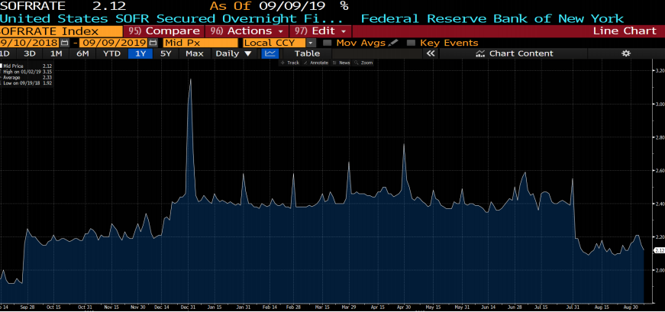

**Figure 2:** USD SOFR Forward Rate Jumps and Turns

Discount Factor and Forward Rate Formulae

For a given curve the discount factor P(t,T) at payment date T is defined as,

$$P\left(t,T\right)=exp\left(-\int_{u=t}^{T}{f\left(t,u\right) du}\right) (1)$$

By rearranging equation (1) gives the instantaneous forward rate f(t,T) as,

$$f\left(t,T\right)=- \frac{∂}{∂T}ln⁡( P\left(t,T\right) ) (2)$$

where t denotes the valuation date, T the cash flow payment date and f(t,T) is the forward rate at time T.

Yield Curves: Incorporating Jumps and Turn-of-Year (ToY) Effects

We can adjust forward rate and discount formulae to incorporate jumps and turns by incorporating an overlay curve, which is tantamount to applying a spread ε to the forward rate on jump or turn date τ as illustrated in (figure 3).

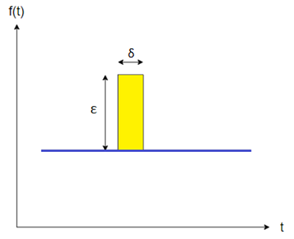

**Figure 3**: Flat Forward Rate Curve with a Jump

If we consider a single daily jump ε at time τ over a time period δ of 1 day, then the adjusted forward rate f*(t,T) at time T can be modelled as,

$$f^{*}\left(t, T\right)=f\left(t, T\right)+ε . 1\{ τ=T \} (3)$$

where $1\{ τ=T \}$ is an indicator function that is equal to 1 if the jump at time τ occurs on the forward date T and is zero otherwise. Similarly $1\{ τ≠T \}$ is the indicator function that is equal to 1 if the jump at time τ does not occur on the forward date T and is zero otherwise.

Similarly adjusted discount factors P*(t,T) can be calculated as,

$$P^{*}\left(t, T\right)=exp\left(-\int_{u=t}^{T}{f\left(t,u\right) du-ε δ .1\{ τ=T \}}\right)$$

The adjusted discount formula must allow for both the case when there is a jump and also when there is not a jump, which gives the below conditional formula,

$P^{*}\left(t,T\right)=\exp\left(-\int_{u=t}^{T}{f\left(t,u\right)du}\right).\left( 1\left\{ τ≠T \right\} +\exp\left(-ε δ\right) . 1\left\{ τ=T \right\} \right)$

***0 if a jump 1 if a jump***

***1 if no jump 0 if no jump***

giving,

$${ P}^{*}\left(t,T\right)= P\left(t,T\right) . \left( 1\left\{ τ≠T \right\} +\exp\left(-ε δ\right) . 1\left\{ τ=T \right\} \right) (4)$$

***Unadjusted Jump or***

***Discount Factor ToY Adjustment***

when τ ≠ T equation (4) gives,

$${ P}^{*}\left(t,T\right)= P\left(t,T\right) . \left( 1 +\exp\left(-ε δ\right) . 0 \right)$$

$$=P(t,T)$$

and when τ = T we have,

$${ P}^{*}\left(t,T\right)= P\left(t,T\right) . \left( 0 +\exp\left(-ε δ\right) . 1 \right)$$

$$=P\left(t,T\right).\exp\left(-ε δ\right)$$

Finally in the generic case if we consider a table or series of n daily jumps and turns we can modify equation (3) and (4) to incorporate these jumps as follows,

$$f^{*}\left(t,T\right)=f\left(t,T\right)+\sum_{i=1}^{n}{ε_{i} . 1\left\{ τ_{i}=T \right\}} (5)$$

and

$$P^{*}\left(t,T\right)=P\left(t,T\right) \left(\prod_{i=1}^{n}{ 1\left\{ τ_{i}≠T \right\} }+\prod_{i=1}^{n}{\exp\left(- ε_{i}δ\right) . 1\left\{ τ_{i}=T \right\} }\right) (6)$$

Turn-of-Year Example:

Consider the following turn table of daily turn points,

|  |  |
| --- | --- |
| Turn, ε | Time, τ |
| 1.00% | 2.0 |
| 0.75% | 3.0 |
| 0.25% | 4.0 |

Firstly let’s evaluate the adjusted forwards with valuation date t = 0 for forward times T = 1, 2, 3, 4 and 5.

Using equation (5) we have,

f*(0,1) = f(0,1) + ( 1.00% x 0 + 0.75% x 0 + 0.25% x 0 ) = f(0,1)

f*(0,2) = f(0,2) + ( 1.00% x 1 + 0.75% x 0 + 0.25% x 0 ) = f(0,2) + 1.00%

f*(0,3) = f(0,3) + ( 1.00% x 0 + 0.75% x 1+ 0.25% x 0 ) = f(0,3) + 0.75%

f*(0,4) = f(0,4) + ( 1.00% x 0 + 0.75% x 0 + 0.25% x 1 ) = f(0,4) + 0.25%

f*(0,5) = f(0,5) + ( 1.00% x 0 + 0.75% x 0 + 0.25% x 0 ) = f(0,5)

Secondly the adjusted discount factors forwards with valuation date t = 0 for forward times T = 1, 2, 3, 4 and 5 are as below.

Using equation (6) we have,

$\prod_{i=1}^{3}{1\left\{ τ_{i}≠1 \right\}}$ = 1 x 1 x 1 = 1

P*(0,1) = P(0,1) x ( 1 + exp(-1.00% δ ) x 0+ exp(-0.75% δ) x 0 + exp(-0.25% δ) x 0 )

= P(0,1)

$\prod_{i=1}^{3}{1\left\{ τ_{i}≠2 \right\}}$ = 0 x 1 x 1 = 0

P*(0,2) = P(0,2) x ( 0 + exp(-1.00% δ ) x 1+ exp(-0.75% δ) x 0 + exp(-0.25% δ) x 0 )

= P(0,2) x exp(-1.00% δ )

$\prod_{i=1}^{3}{1\left\{ τ_{i}≠3 \right\}}$ = 1 x 0 x 1 = 0

P*(0,3) = P(0,3) x ( 0 + exp(-1.00% δ ) x 0 + exp(-0.75% δ) x 1 + exp(-0.25% δ) x 0 )

= P(0,3) x exp(-0.75% δ)

$\prod_{i=1}^{3}{1\left\{ τ_{i}≠4 \right\}}$ = 1 x 1 x 0 = 0

P*(0,4) = P(0,4) x ( 0 + exp(-1.00% δ ) x 0 + exp(-0.75% δ) x 0 + exp(-0.25% δ) x 1 )

= P(0,4) x exp(-0.25% δ)

$\prod_{i=1}^{3}{1\left\{ τ_{i}≠5 \right\}}$ = 1 x 1 x 1 = 1

P*(0,5) = P(0,5) x ( 1 + exp(-1.00% δ ) x 0+ exp(-0.75% δ) x 0 + exp(-0.25% δ) x 0 )

= P(0,5)

As we can see from the results only forwards and discount factors observed on turn dates are adjusted for turns.

1. A basis point (bps) is 1/100th of a percent i.e. 0.01%
2. Secured Overnight Funding Rate (SOFR) based on US Treasury repurchase market transactions and published by the Federal Reserve Bank of New York (FED).
3. Also known as MPC swaps; examples include USD FOMC swaps and EUR ECB swaps which are short-dated single period swaps between central bank meeting and rate setting dates.